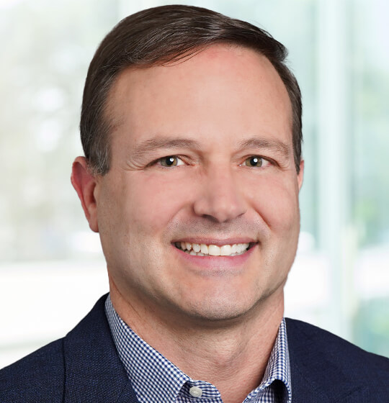
Michael Rubin
Michael Rubin focuses his practice on issues involving occupational safety and health law. He advises and represents employers across multiple industries and around the country in connection with OSHA inspections, investigations, and enforcement actions. He also develops and audits safety programs and policies and counsels employers on related risk-management strategies. He has hands-on experience managing accident investigations—including those involving multiple fatalities—and regularly represents employers before, during, and after the OSHA inspection process. Michael regularly contests citations on behalf of employers and negotiates for the withdrawal and/or settlement of citations. With nearly 20 years of litigation experience, Michael is a skilled trial attorney who engages in litigation before the Occupational Safety and Health Review Commission. Michael has tried multiple OSHA matters.
Michael has assisted clients in OSHA matters pending in Alabama, Arizona, California, Colorado, Connecticut, Delaware, Florida, Georgia, Hawaii, Illinois, Indiana, Iowa, Kansas, Louisiana, Massachusetts, Michigan, Minnesota, Montana, Nebraska, New Jersey, New York, North Carolina, North Dakota, Ohio, Oklahoma, Oregon, Pennsylvania, South Carolina, Texas, Virginia, and Washington.
Frequently called on to speak on OSHA legal issues at local and national industry events, Michael has presented at safety conferences hosted by EHS Today, BLR, American Society of Safety Professionals, and Associated Builders and Contractors, among others. He also serves as a guest lecturer at Columbia University in the Construction Management Master’s Program.

