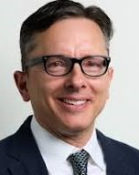

Ray Master, CSP

Ray Master has been a practicing safety professional for over 30 years. As a recognized leader in the field, he is uniquely qualified in the behavioral, cultural, organizational, and technical aspects of safety performance and improvement. Ray holds BS (’91) and MS (‘00) degrees in Safety Sciences from Indiana University of Pennsylvania and is currently studying part-time in the MSc program in Human Factors & System Safety at Lund University in Sweden. While primarily servicing the construction industry, his experience spans a range of industry domains to include real estate, transportation, power (nuclear & fossil), oil & gas, commercial aviation, emergency management, environmental remediation, risk management & insurance, and healthcare & life sciences. Ray has held adjunct professor positions at both NYU and Columbia University. He is board certified as a CSP by the Board of Certified Safety Professionals since 1994. As a notable highlight, Ray was the lead safety professional servicing the construction workforce at the World Trade Center Disaster Recovery Project.

